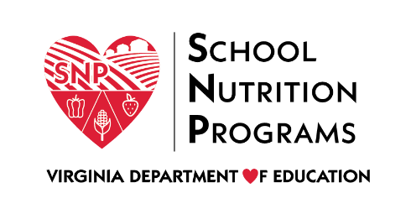
MEDIA RELEASE 2022-2023
POLICY FOR PROVIDING FREE MEALS FOR SCHOOL DIVISIONS PARTICIPATING IN THE COMMUNITY ELIGIBILITY PROVISION (CEP) FOR ALL SCHOOLS IN THE DIVISION (Divisionwide)
08/02/2022
Greene County Public Schools
today announced its policy for providing free meals to all children served under the National School Lunch and School Breakfast Programs. Each school and/or central school nutrition office has a copy of the policy, which may be reviewed by any interested party.
All schools in the division will be participating in the Community Eligibility Provision (CEP) as implemented under the Healthy, Hunger-Free Kids Act of 2010. Enrolled students will be provided a nutritious meal for breakfast and lunch each day at no charge to the household. Households will not be required to submit a meal application form to receive meals at no charge. Each household will receive a letter informing them of the program, including contact information for any questions.

Any questions can be directed to:
Name: Samantha French, MS, RD
School Nutrition Program Director
Address: 64 Monroe Drive PO Box 436
Stanardsville, VA 22973
Phone: 434-939-9096
Email: sfrench@greenecountyschools.com

USDA Nondiscrimination Statement
In accordance with federal civil rights law and U.S. Department of Agriculture (USDA) civil rights regulations and policies, this institution is prohibited from discriminating on the basis of race, color, national origin, sex (including gender identity and sexual orientation), disability, age, or reprisal or retaliation for prior civil rights activity.
Program information may be made available in languages other than English. Persons with disabilities who require alternative means of communication to obtain program information (e.g., Braille, large print, audiotape, American Sign Language), should contact the responsible state or local agency that administers the program or USDA’s TARGET Center at (202) 720-2600 (voice and TTY) or contact USDA through the Federal Relay Service at (800) 877-8339.
To file a program discrimination complaint, a Complainant should complete a Form AD-3027, USDA Program Discrimination Complaint Form which can be obtained online at: https://www.usda.gov/sites/default/files/documents/USDA-OASCR%20P-Complaint-Form-0508-0002-508-11-28-17Fax2Mail.pdf, from any USDA office, by calling (866) 632-9992, or by writing a letter addressed to USDA. The letter must contain the complainant’s name, address, telephone number, and a written description of the alleged discriminatory action in sufficient detail to inform the Assistant Secretary for Civil Rights (ASCR) about the nature and date of an alleged civil rights violation. The completed AD-3027 form or letter must be submitted to USDA by:
- mail:
U.S. Department of Agriculture
Office of the Assistant Secretary for Civil Rights
1400 Independence Avenue, SW
Washington, D.C. 20250-9410; or
- fax:
(833) 256-1665 or (202) 690-7442; or
- email:
program.intake@usda.gov
This institution is an equal opportunity provider.

